**Comparative Case Study of Environmental Sustainability Strategies in Tech Giants : Apple Vs Samsung**

Ishrat Jahan Shimu Md Siamul Islam Shayon

Department of Computer Science Department of Computer Science

and Engineering and Engineering

East West University Dhaka, Bangladesh East West University Dhaka, Bangladesh

[ij2245959@gmail.com](mailto:ij2245959@gmail.com) [S.i.shayon@gmail.com](mailto:S.i.shayon@gmail.com)

Korobi Sarker Amit Ghosh Sheshir

Department of Computer Science Department of Computer Science

and Engineering and Engineering

[2020-1-60-161@std.ewubd.edu](mailto:2020-1-60-161@std.ewubd.edu) [2019-1-60-263@std.ewubd.edu](mailto:2019-1-60-263@std.ewubd.edu)

**Abstract :**

**This case study undertakes a comparative analysis focusing on the environmental Sustainability of two prominent technology giants, Apple and Samsung.By analyzing their sustainability report, this case study aims to compare and contrast of their proactive steps to analyze, reduce E-waste, optimize energy efficiency, adopt renewable energy sources and implement responsible supply chain practices.Since 1998,Samsung emphasizes sustainable management practices establishing e-waste center and developing their products which is environmentally friendly and their green approach led to substantial reductions in greenhouse gas emission and significant recycling achievements.Since 2008, Apple have also focus on environmental labs,energy efficient designs, and achieving 100% renewable electricity usage accross its operation by 2018.**

**Despite different timelines and approaches , both companies have committed to reducing environmental impact through innovative strategies and demonstrating their dedication to sustainability.**

**Keywords :**Sustainability strategies,Green IT,,Apple,Samsung,Carbon Footprint reduction,Renewable Energy Adoption,Eco-Friendly Practices,Energy Efficiency, Recycling, Manufacturing, Water Resolve Management ,GHG emissions etc.

**Introduction**

The technology industry ,by its nature consumes substantial energy,produces electronic waste,and exerts significant environmental pressures .Therefore, fostering sustainable practices within this sector is critical for mitigating these impacts.Technology industry, sustainability initiatives encompass various facets, including reducing carbon footprints, optimizing energy efficiency, adopting renewable energy sources, employing eco-friendly materials, implementing responsible supply chain practices, and prolonging product life cycles through recycling and responsible disposal.Apple and samsung company are also conscious of that topic that's why they started to analysis how to reduce e-waste , manufacture them, recycle them , optimize energy efficiency ,adopting renewable energy sources, employing eco-friendly materials,implementing responsible supply chain practices and prolonging product life-cycles through recycling and responsible disposal.This case study mainly focus on to conduct a comparative assessment of the sustainability initiatives delineated for this two companies.

**Overview of Initiative Sustainability Approaches**

Samsung is a global company and it has billions of consumers who trust their company and use their products on a daily basis.Samsung has a sustainable management system which delivers in the form of value comparison of electronic value and social value and over the years it tools various approaches to sustainability.

Based on Samsung Green Approach; it took fighting environmental issues as a necessity and a corporate investment.In 1998 for that tt established an E-waste and recycling center to encourage better use of waste products.Also in 2004 Samsung further increases its effort aggressively by developing environmentally friendly products and started the Ecodesign process that test or examine the energy and efficiency resource, as well as the environmental damage of a proposed product right from its development stage.[1].Since then they have tools several approach to prevent e-waste and make their products for less energy consumption.Samsung plunged into the vision to lead global response with emphasis on low carbon emissions and green growth. And so between 2009 to 2018 Samsung was able to achieve a reduction in greenhouse gas emission by 243.1 million tones which were seen to be almost equal to 1.5 billion people's refrigerator usage for a year. And through its e-waste program, Samsung was able to recycle tons of plastic into its products.[1]

Apple is also a well known company billions of people use their product and whenever their new version of products are released people go crazy to buy those products.Considering E-watw and environmental issues Apple also took several approaches to reduce energy usages ,made sustainable thinking to save our environment.In 2008 Apple also started designing its product to use less energy which led to less than 70% energy usage for Apple's average product.2005 An environmental Analysis Lab was built to check for hazardous and harmful substances in a product. And also eliminate Cadmium, a harmful material to both humans and the environment. Apple did something similar by creating an environmental testing Lab to check their materials from any harmful compound to keep them out of their products.[2]. In September 2019, its market cap hit $ 1 Trillion (Pratap, 2019). Apple claims that it has made significant progress in its manufacturing and supply chain. By the end of 2018, it had achieved the goal of using 100 per cent renewable electricity for its operations. For its facilities in 34 countries around the world, the company is sourcing renewable energy. All final assembly sites for iPhone, iPad, Mac, Apple Watch, AirPods and HomePod are now certified Zero Waste to Landfill, while conserving billions of gallons of water and reducing greenhouse gas emissions(Apple’s Supplier Responsibility Progress Report, 2019).

**Sustainability Strategy**

On the sustainable strategy we have analyzed both companies' approaches and strategies and target carbon neutrality, enhance energy efficiency, manage water resources, reduce E-waste and utilize recycled materials in packaging(eco-packaging).

**Carbon Footprint reduction:**

**Apple company**

In 2022, Apple company’s environmental programs avoided over 28 million metric tons of emissions across all scopes, like sourcing 100 percent renewable electricity for its facilities, transitioning suppliers to renewable energy, and using low-carbon materials in products have yielded clear results. They are decoupling business growth from emissions: While their revenue has grown by over 68 percent since 2015, and gross emissions have decreased by over 45 percent. [6]Apple is quite proud of the fact that it has reached carbon neutrality for parts of its operations and it will take until 2030 for all of its products to be fully carbon neural across its manufacturing infrastructure.Until then , the company continues making progress in it efforts to reduce carbon emissions across each subsequent generation.For example, the [iPhone 13's](https://apple.sjv.io/c/159047/435031/7613?&sharedId=zdnet&u=https%3A%2F%2Fwww.apple.com%2Fiphone-13%2F&subId1=zd-__COM_CLICK_ID__-dtp) emissions fell to between 64 Kg CO2e and 71 Kg CO2e, down from the [iPhone 12's](https://apple.sjv.io/c/159047/435031/7613?&sharedId=zdnet&u=https%3A%2F%2Fwww.apple.com%2Fshop%2Fbuy-iphone%2Fiphone-12&subId1=zd-__COM_CLICK_ID__-dtp) range of 68 Kg CO2e to 80 Kg CO2e for comparable models.[5]

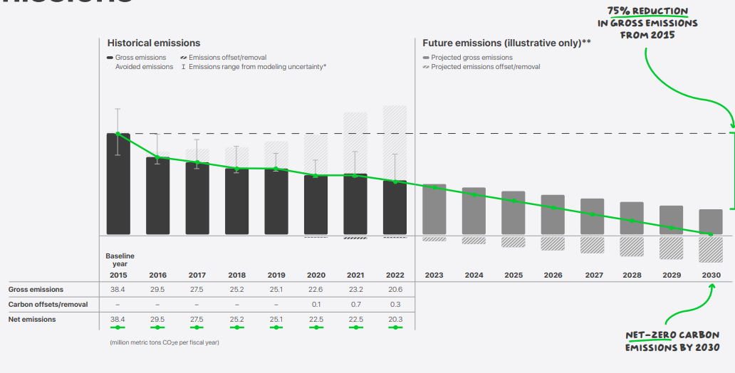

**Figure 1: Apple company Net-Zero carbon emissions by 2030.**

**Samsung Company**

Like Apple , Samsung wants its product’s lifecycle to be cyclical, so in September 2022, we released our mid-to-long-term environmental management strategy which specifies achieving Net-Zero by 2050.[4].In 2019,they obtained the industry’s first Carbon Footprint certification from the Carbon Trust for the Universal Flash Storage (UFS). Since then, Carbon-Footprint certified across a wide range of products – including eight in DRAM/ SSD/ memory card (2020), four in system semiconductor and twenty in DRAM/SSD/memory card (2021), four in system semiconductor, and 15 in DRAM/SSD/ memory card (2022). Moreover, we achieved Carbon Reduction certifications for one UFS (2020) and five DRAM/SSD/UFS/memory cards (2021).[4].

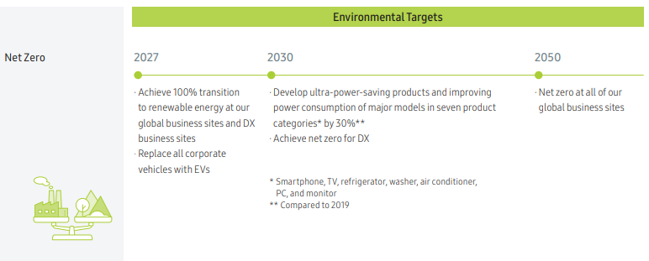

**Figure2:Samsung company Net-Zero carbon emissions by 2050**

**Driving product Energy Efficiency:**

Samsung and Apple are using innovation to tackle climate change to make a meaningful impact on the future of our planet.

**Samsung Company**

Samsung company’s latest products outperform their predecessors in terms of energy efficiency which actually exceeds the first grade rating by their Korean Government.The Bespoke Grande AI washer (25kg) and Bespoke Wind-Free Air Conditioner both exceed this rating by 20% and 10%, respectively. By using the SmartThings AI Energy Mode, energy consumption of washers, air conditioners, and dryers can be further enhanced by up to 60%, 20%, and 35%, respectively.[6].

Besides, for lower-power memory they offer high-performing,power-efficient,and secure solutions tailored to the needs of the data center.they claimed if they replace the world’s Hard Disk Drives(HDDs) with Samsung Solid State Drivers(SSDs) and Dynamic Random-Access memory of Several with Samsung Double Data Rate 5 DRAMs ,approximately 7TWh of energy can be saved per year.

Moreover ,for Low-power Processor Samsung Exynos Processor is integrated with a variety of functions, including the CPU, GPU, Multi-format Codec (MFC), Image Signal Processor (ISP), Display, and Security — along with an NPU and Digital Signal Processor (DSP) for AI in addition to the 5G modem. Furthermore, our proprietary Advanced Multi-IP Governor (AMIGO) solution dramatically reduces battery consumption.[6]

**Apple company**

Apple also takes many steps towards energy efficiency.Employing holistic design strategies apple continually enhances energy efficiency across product generations.Apple claims to have to cut overall product energy use across all major product lines by more than 70% since 2008.after a lot of progress in 2022 they made in reducing energy use in products like MacBook pro with M2 Pro and M2 Max and new Apple TV ak designed to use nearly 30% less power.In 2022, we further improved energy efficiency at data centers by deploying our own server design, developed with a focus on energy and computing efficiency, resulting in over 56.7 million kilowatt-hours per year in energy savings. This work builds on previous efficiency efforts in our data centers, including developing a specification requiring our servers to be powered by high-efficiency power supplies — exceeding even the efficiency requirements for ENERGY STAR certification — which was deployed to hundreds of thousands of servers in 2021, resulting in over 4 million kilowatt-hours per year in energy savings.[6] They have set a goal to use 100% recycled cobalt, tin,gold and rare earth elements in key components by 2025.

**Water Resource Management:**

**Samsung company**

Samsung Electro-Mechanics is operating a water reuse improvement plan to meet our goal of a 36.7% water reuse rate by 2030. In 2022, we began recycling concentrated water, washing water, and effluents from wastewater and expanded the reuse facility to process approximately 528,000 tons per year. We are also investing in water treatment facilities to analyze related risks and maintain water quality standards. To immediately respond to potential water outages, we have implemented effective measures such as utilizing reserves with a capacity exceeding 12 hours and establishing redundant supply sources. Our systematic monitoring system allows us to identify and analyze the status of water resources at our business sites. Issues and areas that require improvements are reported to management and instant action is taken to implement necessary measures

Besides , Samsung recognizes the water resources are essential for product manufacturing and business operation and so they improve water reuse rate and increase from 23.6% in 2021 to 26.1% in 2022.

**Apple company**

Apple also feels the same so they reduce water impacts on manufacturing of their product, facility operations and other service purposes.So they look to system and processes that uses less water or reuse water so that they can limit excess water consumption and where as possible they eliminate waste .they claimed that up to 44% of the water that they use at corporate location is discharged back into the local water system rather than consumed.After employed several approaches ,including using cascade and counterflow rinsing processes, which helped retain 75 to 85 percent of the water used during metal finishing. This process improvement has the potential to save millions of gallons of freshwater annually when applied at scale.[6]

**Reduce E-Waste and Recycling and Expansion of Renewable Energy Use:**

**Samsung company**

Samsung’s initiative aims to reduce emission and enhance recycling through innovation and strategic goals.They focus on Ultra-power-saving technology, aiming to cut power consumption in data centers and devices by 2025 and improving product efficiency by 30% by 2030.Their Scope 3 Emissions Management involves auditing and targets across supply chains for accurate emissions assessment.They strive for resource circularity by using recycled materials in electronics and recovering resources from discarded products .Expanding recycled resin usage to 50% by 2030 and all plastics parts by 2050 .They are dedicated to E-waste collection , aiming for 10 million tones by 2030 and establishing mineral recovery from waste batteries.[4].they engage in diverse activities to transition to 100% renewable energy at all their business site by 2050 and their total amount of renewable energy use in 2022 stood at 8704 GWH a 65% increase from the previous year reaching a 31% transition rate.

**Apple company**

For reducing E-waste and improve Recycling apple also takes different approaches .It is committing to creating circular supply chains and products designed with responsibility sourced recycled and renewable materials .Apple focus on 4 key pillars for circularity: sourcing and efficiency, product longevity, collection and recovery , lastly expanding recycled content.It prioritizes 14key materials which constituting 87% of product mass and aiming for closed-loop supply chains(2022).Approximately, 20% of materials shipped in 2022 consisted of recycled and renewable content, Milestones including using 100% recycled copper foil in Ipads,developing a brass alloy from recycled copper zinc for Mac studio and they doubling recycled cobalt use tt25% shipped in 2022 for iphones,ipads and Mac devices.

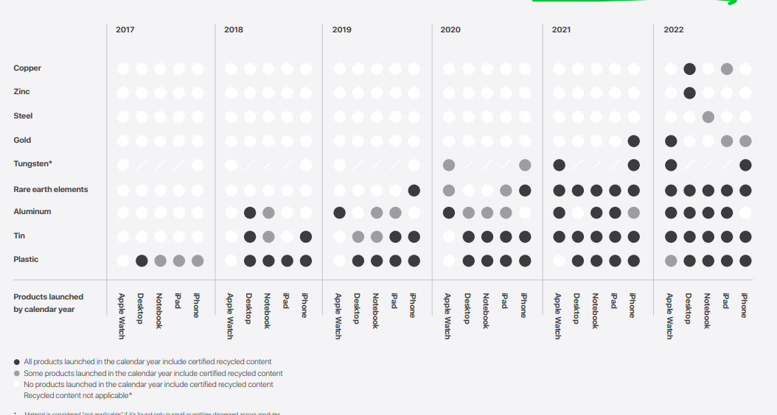

**Figure3: Apple recycling materials for their products (2017-2022)**

**Eco-Package Solutions:**

**Apple company**

A company uses plastics for many purposes which affect our climate silently ,increasing our planet temperature day by day.After addressing this Apple focus on implementing innovative alternatives to the small uses to plastics across their Packaging like labels and lamination which help then reduce use of plastic. To eliminate the need for labels on the latest iPhone models iPhone 14 and iPhone 14 Pro they introduced digital printing directly on the back of boxes and developed a custom high-resolution ultraviolet inkjet printer that can print on demand at the manufacturing facilities where the iPhone is packaged.[6] Besides they estimate that eliminating the labels will avoid over 300 metric tons of plastic, over 150 metric tons of paper, and over 3700 metric tons of carbon emissions.They are closing in on their goal to eliminate plastic from their packaging by 2025.

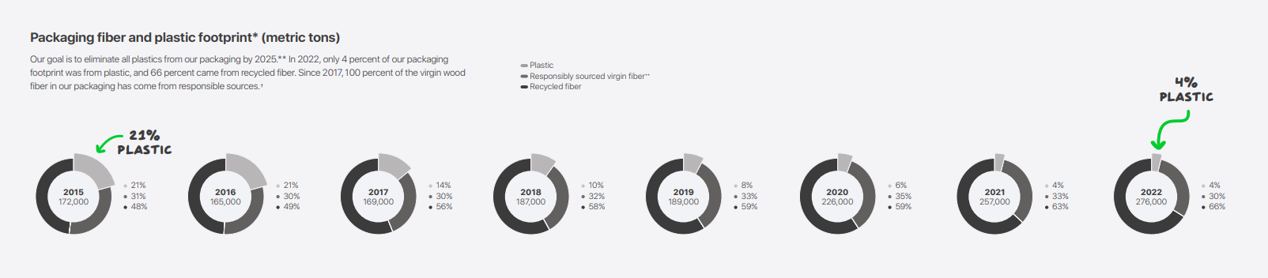

**Samsung Company**

Samsung uses recycled expandable polystyrene (EPS) cushions in the packaging of our major TV models and are expanding their application to all monitor and signage models released in 2023.Since 2020 ,They have engaged Their users in upcycling the packaging materials of their TVs – repurposing them into small furniture and objects for pets and have expanded the scope to packages of all TV models and select home appliances including air purifiers, etc.) released since 2021. Mobile Devices For the Galaxy S23 series released in 2023, 100% of the packaging box was made from recycled paper. The plastic films previously attached to the front and back of the product were fully replaced with 100% recycled paper as well. They are continuing our efforts to minimize our environmental impact by eliminating single-use plastic from the packaging and reducing GHG emissions from product transportation by making packages smaller and lighter.[4]

**Comparison**

Apple and Samsung both prioritize environmental sustainability but there have some differences in their approaches.

Apple aims for carbon neutrality across its operations by 2030 and achieving notable milestones in reducing product emissions and striving for 100% recycled and renewable materials in key components by 2025.Contrastingly , Samsung targets net-Zero carbon emissions by 2050 and made stride in product energy efficiency , using ultra high-performing, low power components and smart energy modes , aiming 30% improved product efficiency by 2030.Whereas, Apple also emphasizes energy efficiency,reducing water consumption, minimizing e-waste , and they focus on circular chain achieving nearly 20% recycled and renewable content by 2022. It also innovates packaging to eliminate plastic by 2025.Samsung also employs recycled materials in packaging , eliminating single use plastic and deploying strategies like recycled paper .

Eventually we can say both companies have tried their best to reduce the E-waste , water waste and try to reuse materials, recycling ,eco-packaging for environmental sustainability.

**Conclusion**

As Global technology leaders, Samsung and Apple demonstrate strong dedication with their strategies, to sustainability across their operation and lifecycle of their products and employ unique methods to migrate environmental impacts,emphasizing reduced carbon footprints,enhanced energy efficiency, responsible material usage and waste management etc.

**References:**

1. **Samsung, (2019). How Samsung Has Evolved Its Environmental Stewardship. Retrieved from** [**https://news.samsung.com/us/samsung-global-green-management-initiatives-journey-sustainable-future/**](https://news.samsung.com/us/samsung-global-green-management-initiatives-journey-sustainable-future/)
2. **Apple (2019). Environment; Making without taking sounds impossible. But it’s our goal. Retrieved from** [**https://www.apple.com/environment/our-approach/**](https://www.apple.com/environment/our-approach/)
3. [**https://www.coursesidekick.com/management/370799**](https://www.coursesidekick.com/management/370799)
4. **Samsung Electro-Mechanics. (2023). Samsung Electro-Mechanics 2022-2023 Sustainability Report. Retrieved from [**[**https://www.samsungsem.com/resources/file/global/sustainability/report/SEM_SR2022_EN.pdf**](https://www.samsungsem.com/resources/file/global/sustainability/report/SEM_SR2022_EN.pdf)

**https://www.samsung.com/global/sustainability/media/pdf/Samsung_Electronics_Sustainability_Report_2023_ENG.pdf]**

1. [**Michael Gariffo, Staff Writer**](https://www.zdnet.com/meet-the-team/michael-gariffo/)**,Feb. 16, 2022 at 6:32 a.m. PT Most eco-friendly smartphone? Apple vs Samsung in the race against e-waste https://www.zdnet.com/article/most-eco-friendly-smartphone-apple-vs-samsung-in-the-race-against-e-waste/**
2. **Jackson, L. (2023). Apple_Environmental_Progress_Report. Retrieved from** https://www.apple.com/environment/pdf/Apple_Environmental_Progress_Report_2023.pdf